**Professional Readiness for**

**Innovation, Employability and Entrepreneurship**

**ASSIGNMENT-2**

**PYTHON PROGRAM FOR TEMPERATURE AND HUMIDITY**

## Submitted By

## S.ABIGAIL DERALSHYA

## ROLL NO:961819106002

## INTERNET OF THINGS**–B12-6A2E**

## CODE:

## PYTHON PROGRAM : -

## p=int(input("Enter temperature value: "))

## q=int(input("Enter humidity value: "))

## def hightemp(c,d):

## if (c>=100):

## print("TEMPERATURE DETECTED IS HIGH: ",c)

## if (d>=90):

## print("HUMIDITY DETECTED IS HIGH: ",d)

## print("ENVIRONMENT IS IN GOOD CONDITION")

## print("BUZZER OFF")

## else:

## print("HUMIDITY DETECTED IS LOW: ",d)

## print("HAZZARD DETECTED")

## print("BUZZER ON")

## else:

## print("TEMPERATURE DETECTED IS LOW: ",c)

## print("PLESENT ENVIRONMENT CONDITION")

## hightemp(p,q)

## SNAPS OF THE PROGRAM: *OUTPUT*

## BUZZER OFF:

## *TEMPERATURE DETECTED IS HIGH -HUMIDITY DETECTED IS HIGH*

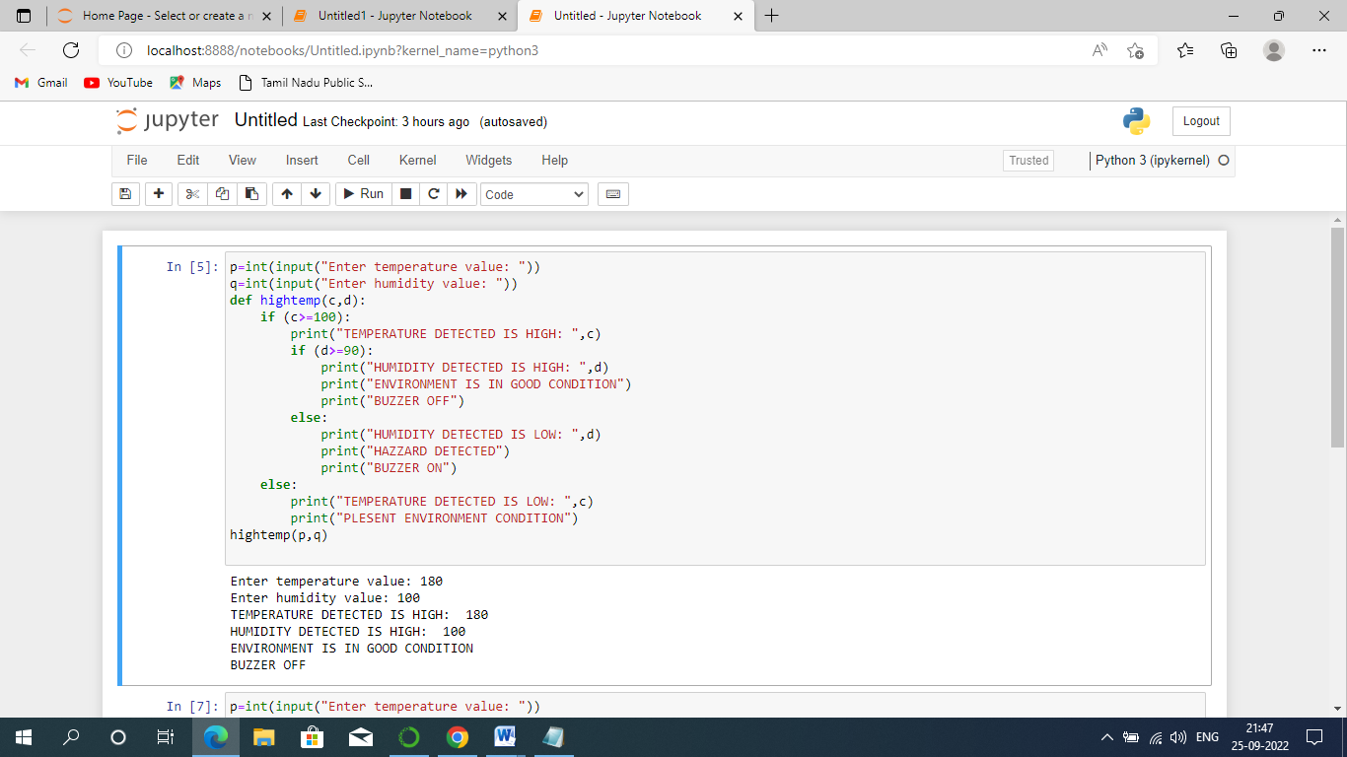

**BUZZER ON:**

***TEMPERATURE DETECTED IS HIGH -HUMIDITY DETECTED IS LOW***

## 